
VICTORIA JUNIOR COLLEGE

JC2 PRELIMINARY EXAMINATIONS 2026

H1 GEOGRAPHY 8834/01

INSERT 3 hours

READ THESE INSTRUCTIONS

The Insert contains all the Resources referred to in the questions.

This document consists of 10 printed pages

Resource 1 for Question 1

Map of Manchester 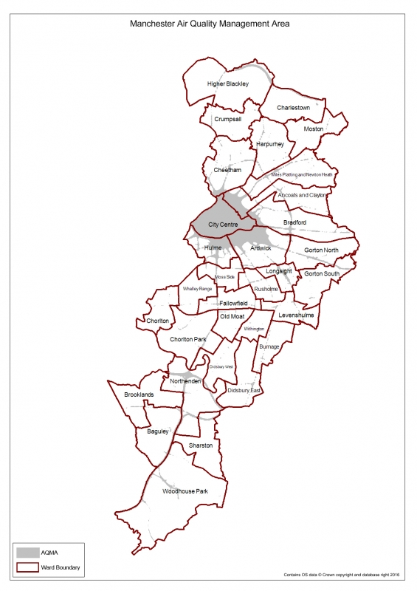

Resource 2A for Question 1

Questionnaire created by students

No. | Question | Options [Score 1(lowest) to 5 (highest)]
1 | How easy is it for you to access essential shops and supermarkets from your home? | ☐ 1  ☐ 2  ☐ 3  ☐ 4  ☐ 5
2 | How easy is it for you to access healthcare facilities such as clinics and pharmacies? | ☐ 1  ☐ 2  ☐ 3  ☐ 4  ☐ 5
3 | How easy is it for you to access public transport from your home? | ☐ 1  ☐ 2  ☐ 3  ☐ 4  ☐ 5
4 | How easy is it for you to access parks and other green spaces? | ☐ 1  ☐ 2  ☐ 3  ☐ 4  ☐ 5
5 | How safe do you feel when walking around your neighbourhood? | ☐ 1  ☐ 2  ☐ 3  ☐ 4  ☐ 5
6 | Overall, how would you rate the liveability of your neighbourhood? | 1 — 2 — 3 — 4 — 5 — 6 — 7 — 8 — 9 — 10  1 – Very low liveability  10 – Very high liveability

Resource 2B for Question 1

Responses collected by students

Question | Didsbury (20) | Ardwick (20) | Hulme (20)
Q1: Access to shops | 4.4 | 3.2 | 4.5
Q2: Access to healthcare | 4.1 | 3.0 | 3.8
Q3: Access to public transport | 4.2 | 3.8 | 4.5
Q4: Access to green spaces | 4.0 | 2.8 | 3.7
Q5: Neighbourhood safety | 4.1 | 2.9 | 3.6
Q6: Overall liveability /10 | 8.4 | 6.1 | 7.6

Resource 3 for Question 1

Site Audit conducted by Students

The students assessed five aspects of the physical environment, giving each criterion a score from 1 to 5.

Site audit criterion | Didsbury | Ardwick | Hulme
1. Accessibility of essential shops | 5 | 3 | 4
2. Accessibility of healthcare facilities | 4 | 3 | 4
3. Accessibility of public transport | 5 | 4 | 5
4. Accessibility of green spaces | 4 | 3 | 4
5. Availability of benches/resting areas | 4 | 2 | 3
Total Site Audit Score /25 | 22 | 15 | 20

Site 3

Resource 4 for Question 2
Population Pyramid of Bruges, Belgium (2024)
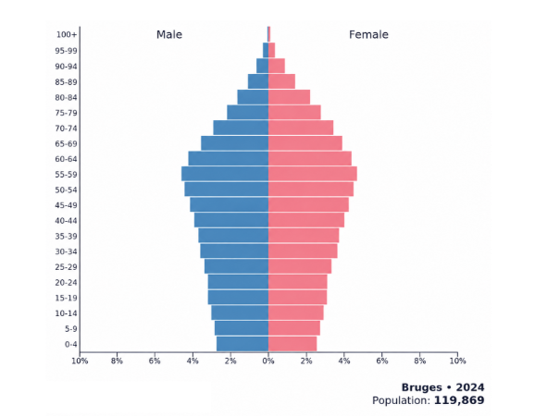

Resource 5 for Question 2
Map of Bruges with dementia friendly facilities
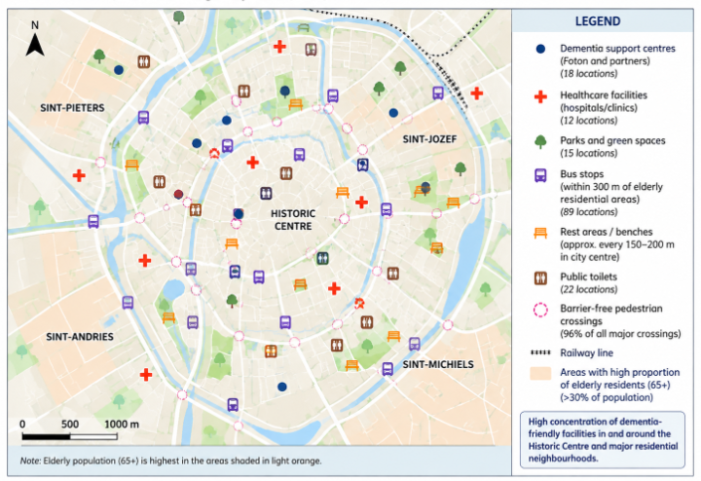

Question 6 for Question 2
Pedestrianisation of Boulevard of Anspach, Brussels City Centre
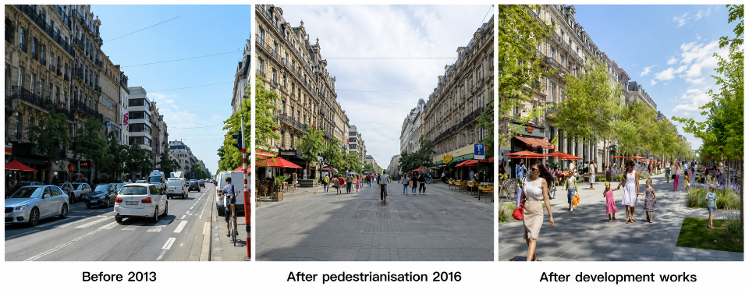

Resource 7 for Question 3
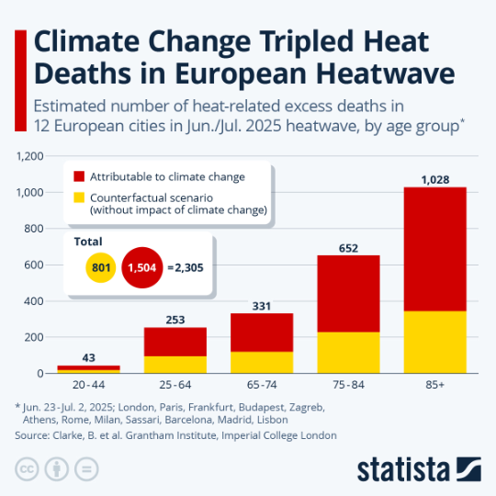
Climate Change related deaths in Europe, 2026

Resource 8 for Question 3
Increasing climate risks under different warming scenarios
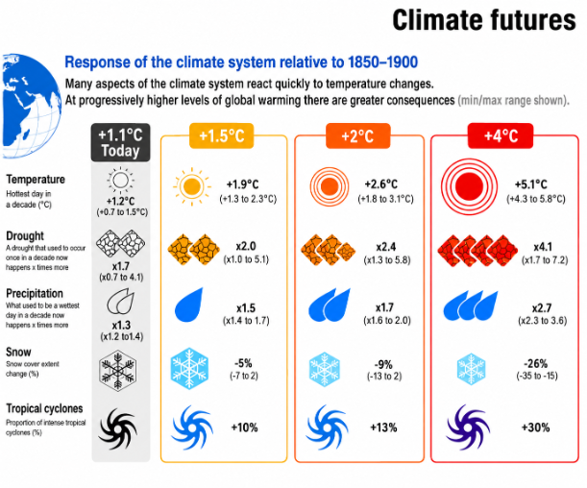

Sources

Resource 1 | https://uk-air.defra.gov.uk/aqma/details?aqma_ref=36
Resource 2 | Author’s own
Resource 3 | Author’s own
Resource 4 | Created with population datasets from StatBel (2024)
Resource 5 | Bruges City Council (2024)
Resource 6 | From pedestrian area to urban and metropolitan project: Assets and challenges for the centre of Brussels:  https://www.researchgate.net/publication/346259415_From_pedestrian_area_to_urban_and_metropolitan_project_assets_and_challenges_for_the_centre_of_Brussels_new_edition_BSI_synopsis
Resource 7 | https://www.statista.com/chart/34783/estimated-excess-deaths-in-european-heatwave/?srsltid=AfmBOoolngIxSUbgplj1kkjhLcQ_G26Au5SBOdy5YcBweSXnBqzlEUAc
Resource 8 | IPCC Assessment Report 6: Working Group 1 report – Summary for Policymakers

